Capstone Project – Web Scaping and Machine Learning Project
- Rohinth Shanmugasundaram
- DADS AUG 2025 Batch B
Introduction:
This project focuses on applying data science and machine learning techniques to analyse product data collected from an e-commerce platform. The objective was to understand patterns in pricing, ratings, and product categories. Both unsupervised and supervised learning methods were used to extract insights. The project demonstrates how data quality and feature selection impact model performance.
Project Overview:
The project involved collecting product data through web scraping, followed by cleaning, exploration, and modelling.
Key variables analysed included
- product price,
- rating, and
- category.
Unsupervised learning was used to identify natural groupings in the data, while supervised learning was applied to predict product categories. Multiple models were evaluated and compared using accuracy and F1-score.
Web Scraping:
Product data was collected from a publicly available e-commerce test website using Python libraries such as Requests and Beautiful Soup. The scraped attributes included product name, price, category, and rating. Pagination handling ensured a sufficient number of observations for analysis. The dataset was exported to CSV format for further processing.
Used – https://books.toscrape.com/ website to pull books across different genre’s or category.
Data Cleaning:
Before Cleaning:
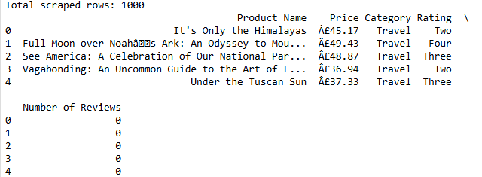
Data cleaning involved handling missing values, correcting formatting issues, and converting data types appropriately.
Price values were standardized into numeric format – all the rows the price were in Euros they were stripped from the numeric column
Ratings were mapped into consistent numerical representations. Duplicate entries and irrelevant records were removed to maintain data integrity. These steps ensured the dataset was suitable for modelling and analysis.
Data After Cleaning:
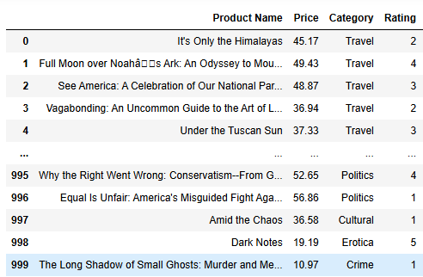
Exploratory Data Analysis (EDA):
Descriptive Statistics:
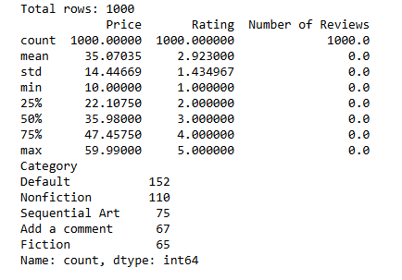
EDA revealed that book prices were relatively evenly distributed within a specific range, indicating no extreme outliers.
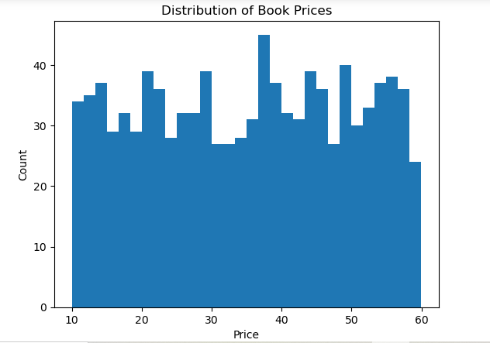
Rating distribution showed a balanced spread across all rating levels.
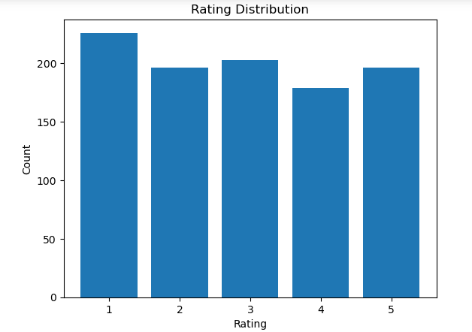

- Book prices are widely distributed across the range, indicating the presence of both low-priced and premium books in the dataset.
- There is no strong price concentration, suggesting a relatively balanced pricing strategy across products.
- Ratings are fairly evenly distributed from 1 to 5, with no extreme skew toward only high or low ratings.
- The presence of all rating levels indicates diverse customer satisfaction levels across categories.

Unsupervised Learning
K-Means clustering was used to identify natural groupings based on price and rating.
The elbow method indicated a noticeable reduction in inertia at four clusters, suggesting an optimal clustering structure. Additionally, the silhouette score of 0.428 confirmed that the resulting clusters were reasonably well separated and meaningful.

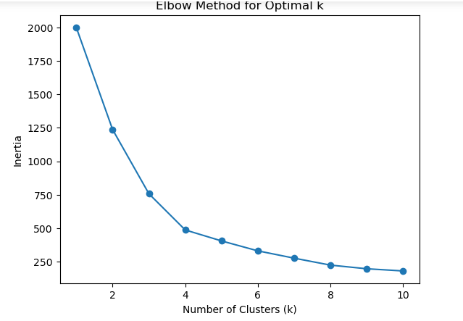
Clusters showed patterns where products were grouped primarily by pricing tiers and rating levels. The analysis indicated that price had a stronger influence on clustering than rating. These findings provided insight into customer perception trends.
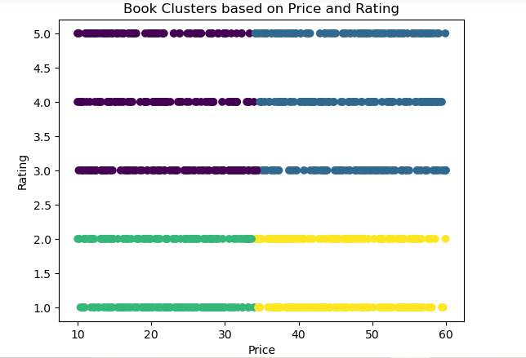

Feature Scaling
Feature scaling was applied using standardization to normalize price and rating values before modelling. This step was necessary for algorithms sensitive to feature magnitude, such as K-Means, Logistic Regression, SVM, and KNN. Scaling ensured that no single feature dominated the learning process.
- The Rating was converted to string for grouping
- The category was encoded to numeric for prediction
- They were scaled down to unique small-scale values.

Supervised Learning
Multiple classification models were implemented to predict product category using price and rating as input features.
- Logistic Regression was applied to examine linear separability and achieved an accuracy of approximately 21% with an F1-score of around 0.14, indicating limited linear relationships between features and categories.
- Support Vector Machine (SVM) explored non-linear boundaries and produced similar performance, with accuracy near 19–22% and F1-scores improving slightly after tuning, suggesting marginal benefits from complex decision boundaries.
- K-Nearest Neighbors (KNN) analysed similarity based on feature distance and showed moderate performance, with accuracy around 19–20% and F1-scores near 0.19 after optimization, indicating some improvement when neighborhood parameters were tuned.
- Random Forest evaluated non-linear feature interactions through ensemble decision trees and achieved accuracy between 17–18% with F1-scores around 0.17, reflecting stable but limited predictive capability.
- XGBoost applied gradient boosting techniques and delivered comparable results, with accuracy close to 18–19% and F1-scores near 0.18, reinforcing that feature informativeness, rather than model complexity, was the primary factor influencing performance.
however, both ensemble models showed only modest gains, reinforcing that limited feature informativeness constrained overall predictive accuracy.

Model Comparison
Model comparison revealed that Logistic Regression and SVM achieved the highest accuracy among the tested models. Ensemble methods like Random Forest and XGBoost did not significantly outperform simpler models. This suggests that feature limitations had a greater impact than algorithm complexity. The findings highlight the importance of feature relevance in classification tasks. Model performance improved when category imbalance was reduced.
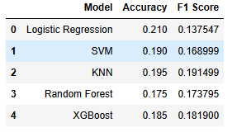

Hyperparameter Tuning
Grid search was used to optimize parameters for KNN, SVM, and Random Forest models. Tuning resulted in modest improvements in accuracy and F1-score, particularly for KNN and SVM. Random Forest showed more stable performance after optimization.
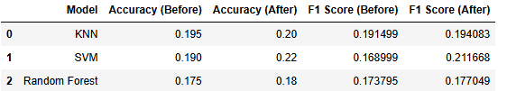
However, improvements were limited, confirming that feature informativeness constrained performance. This step reinforced that tuning enhances stability rather than overcoming weak predictors.

Conclusion
The project demonstrated that unsupervised learning was effective in identifying natural groupings within the dataset based on price and rating.
- K-Means clustering revealed meaningful segments, suggesting that these features capture general patterns in product positioning.
- However, supervised learning models showed limited success in predicting product categories, indicating that price and rating alone are weak predictors of labelled outcomes. The contrast between the two approaches highlights that while the data contains inherent structure, the selected features were insufficient for accurate classification.

